Install
Download and install Java (JDK) 7 at: http://www.oracle.com/technetwork/java/javase/downloads/jdk7-downloads-1880260.html
Download Maven 3.2.1 at: http://mirrors.digipower.vn/apache/maven/maven-3/3.2.1/binaries/apache-maven-3.2.1-bin.zip
Unzip to D:\Software\. It will look like below:

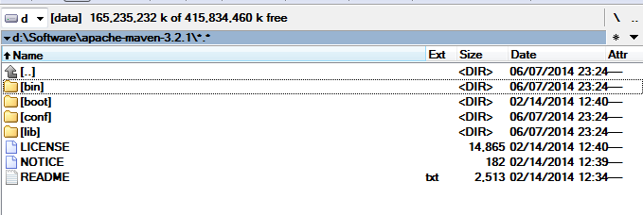

Configure location of Local Repository
Modify D:\Software\apache-maven-3.2.1\conf\settings.xml file, adding below line
<localRepository>D:\Maven Repository</localRepository>
Create Environment variables:
JAVA_HOME = location to java folder. Ex: C:\Program Files\Java\jdk1.7.0
MAVEN_HOME = D:\Software\apache-maven-3.2.1
Add Maven bin folder to PATH environment variable
PATH = ….; % MAVEN_HOME%\bin

